# Republic of the Philippines



Laguna State Polytechnic University

Province of Laguna

Office of Student Affairs and Services

# Siniloan Campus

**Minutes of Meeting**

**Name of the Office:** Office of Student Affairs and Services

**Date:** June 7, 2021

**Time:** 9:00 am – 11:00 am

**Meeting Facilitator:** Mr. Jayson Olayta, Chairperson, OSAS LSPU-SC

**Invites:** OSAS, Publication, SBO Unit and SSC

**Call to Order:** Meeting was called to order by a Google Meet (Online platform)

**Attendees Present:** Mr. Jayson Olayta Mr. Paulo Orioste

Mr. Rommel Octavious Nuestro Mr. Joseph Aldrin Ganibo Mrs. Minerva Fernandez Ms. Marife Hosmillo

Mr. MARK Gil Andico Mr. Eryll Madrazano

Mr. Jerry Reyes Mr. Ivan Jhello Rodel Mr. Jimuel Emperado

**Absent:** None

## Meeting Agenda:

1. Construction of Student Center (Phase II)
2. Other Matters

## Discussion:

The OSAS Chairperson Mr. Jayson Olayta, announced that the SSC and Baybay Granary Publication buildings will be demolished. He informed everyone that the Student Center, which was delayed in construction, would continue to be built before it gradually deteriorated.

He also explained about the funds that will be used to continue the construction of the building. He said that if everyone agrees for Phase 2 construction, a total of 3.1 million will be utilized. This funding will coming from the Publication fund with 1.4 million and the Student Body Organization amounting 1.7 million.

It was also suggested that, if possible, the SSC fund with a total amount of P 486,000.00 will be used for office equipment such as computer sets, tables and chairs, cabinets etc.

Also, he reiterated, that the ground floor of the building will be used for the offices of all accredited SBO Organizations and SSC while the 2nd floor will be the offices of OSAS, Publication, Guidance Office and conference room.

The OSAS Chairperson asked the opinion of the body regarding the utilization fund. SBO Unit Head (Mr. Joseph Aldrin Ganibo) talked about the funds coming from the SBO and agreed that their funds could be used and released for the implementation of the project. Mr. Ganibo mentioned that he would convene for a meeting all of the Organizations to inform regarding the plan and get their opinion on it for formal documentation.

Regarding the funding requested for the Publication, Mr. Eryll Madrazo, Editor-in-Chief of Baybay Granary of Siniloan Campus, expressed his view that they are willing to share the said funds for the continuation of the said project. It was seconded by the unit head Mrs. Minerva

S. Fernandez.

Three of the SSC officers along with their President (Mr. Mark Gil Andico) and their advisers Mrs. Marife Hosmillo and Mr. Jerry Reyes explained their opinion and views for the said project. They all decided and agreed that SSC fund will be used for the purchase of office equipment.

Mr. Rommel Nuestro suggested that the SSC and SBO Unit should spearhead the resolution.

Mr. Ganibo also suggested that it is also necessary to inform and ask the University Legal Council who should sign the resolution for the project and funding for formal documentation and for the security and safety of all.

## Special Note

The resolution will be emailed for review, other potentially additional important information and signing.

It has been confirmed that the e-signature can be used for signing the document/resolution.

## Adjournment

Meeting adjourned at 10:30 in the morning.

## Photo(s):

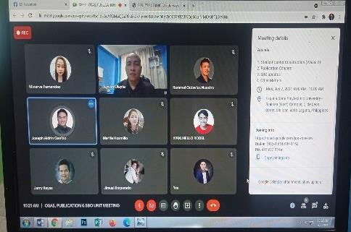 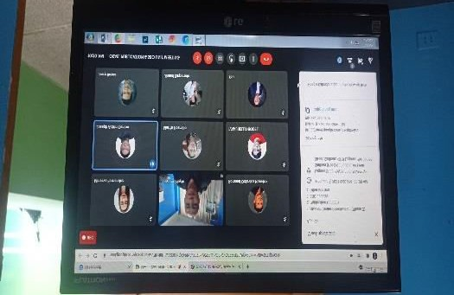

Prepared by: Noted By:



## PAULO M. ORIOSTE JAYSON N. OLAYTA

Admin Aide/Secretary Chairperson, OSAS LSPU-SC